ECPro Instructions

Thank you for taking the time to register with Endeavour Park Equestrian centre. Please follow the instructions on how to create a rider profile on our new booking system (a UK based company – ECPro), make a booking, add payment details and use vouchers codes online.

Once your profile is set up, you’ll be able to book lessons with the click of a button from an app on your phone, tablet or computer.

Only appropriate lessons based on your Level of riding will show. Grading is completed during your first lesson with Endeavour Park Equestrian Centre. Prior to grading, you will still be able to book lessons (Please ignore any pop ups saying you can’t book yet).

Please note, some options such as parties and NDIS clients must be booked manually by emailing bookings@endeavourpark.com.au

Create an account and rider profile on ECPro

- Head to endeavourpark.com.au and click on the book now button

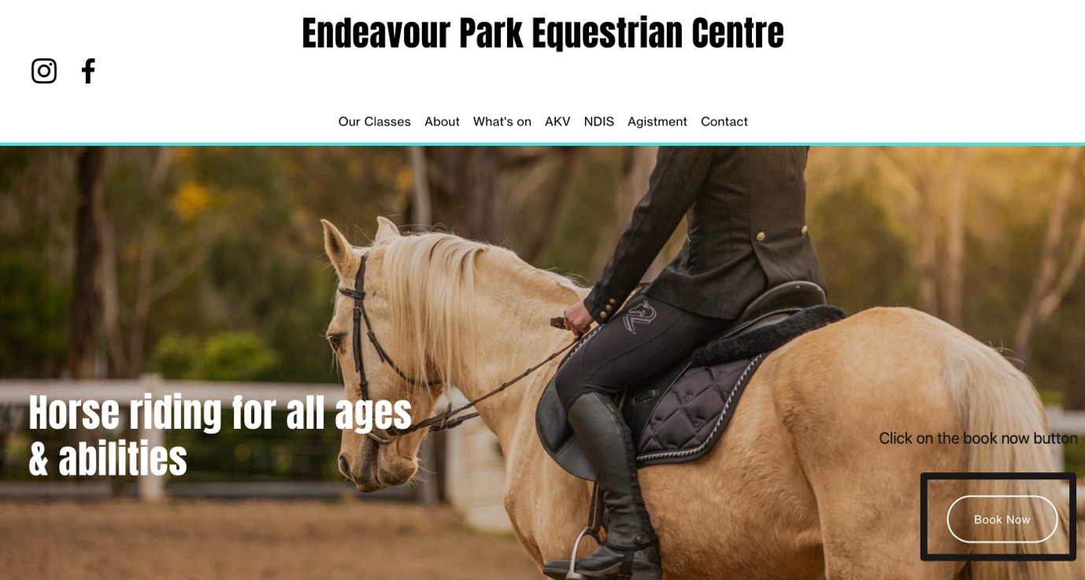

- Click to register if you do not already have an account and fill in the information asked. For any riders under the age of 18, we require that the parents/legal guardian create and fill in the information requested. You can only ride if you have a rider profile.
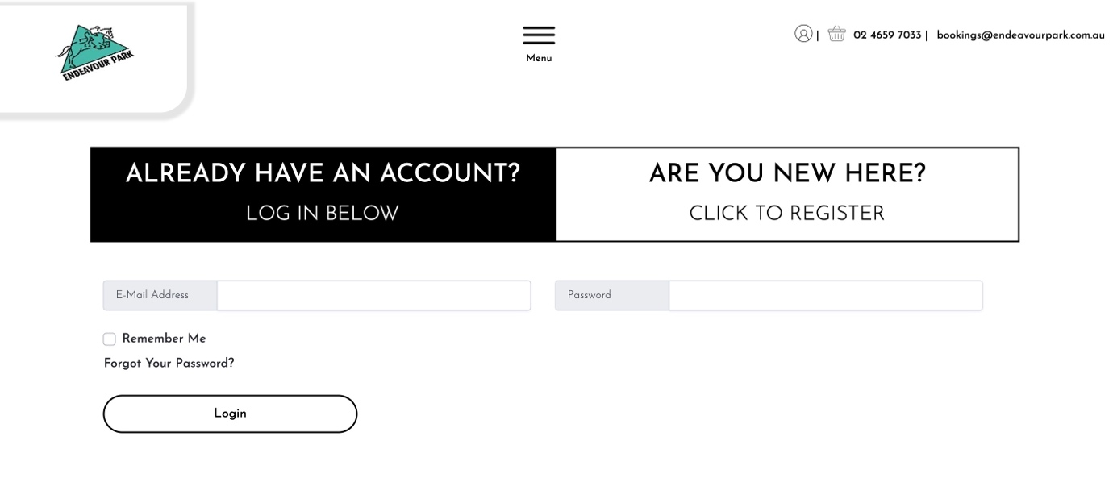
- On your dashboard you will see a message saying you need to ‘add a rider’, go ahead and add a new rider, fill in the required information and press ‘submit’.

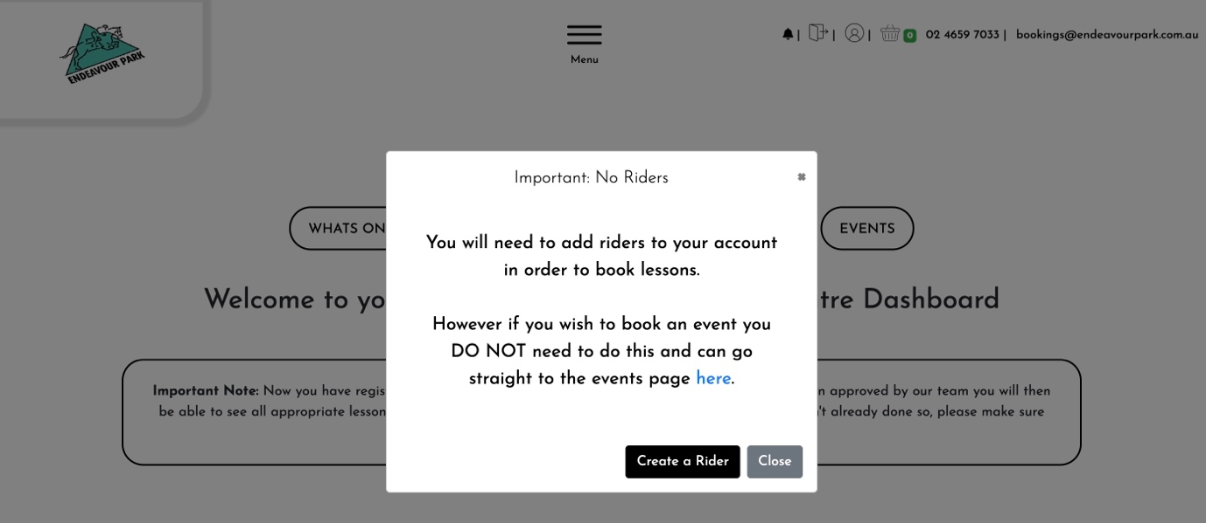

*If you don’t see this pop up, from your dashboard, select’ manage riders’, then select ‘add rider’.
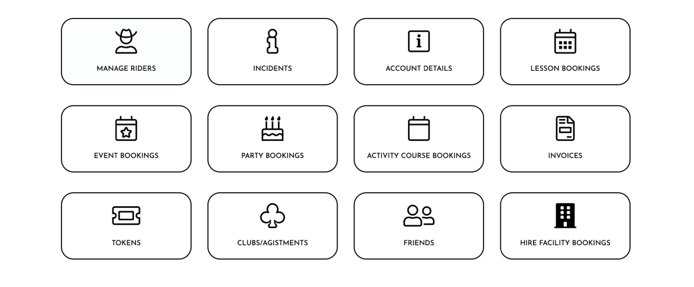
- Fill in the required fields for each rider that will be booking into Endeavour Park.

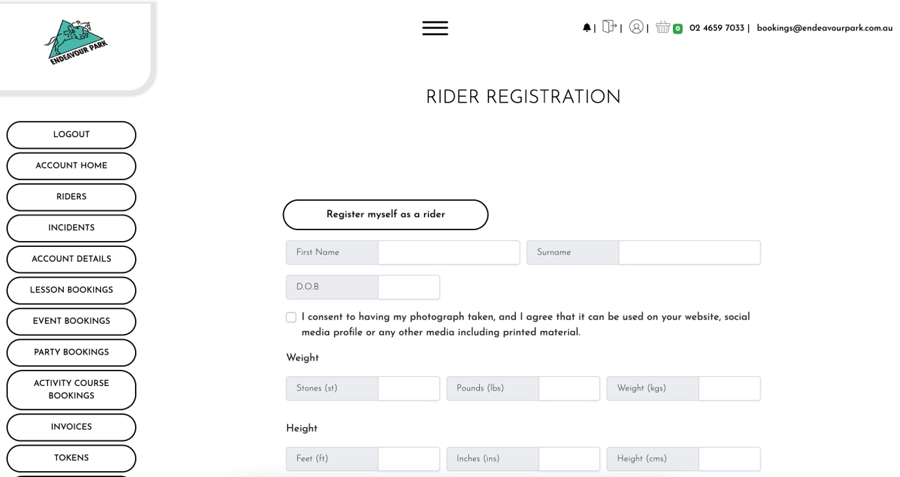

- You should then see a pop up saying you have successfully added a new rider.

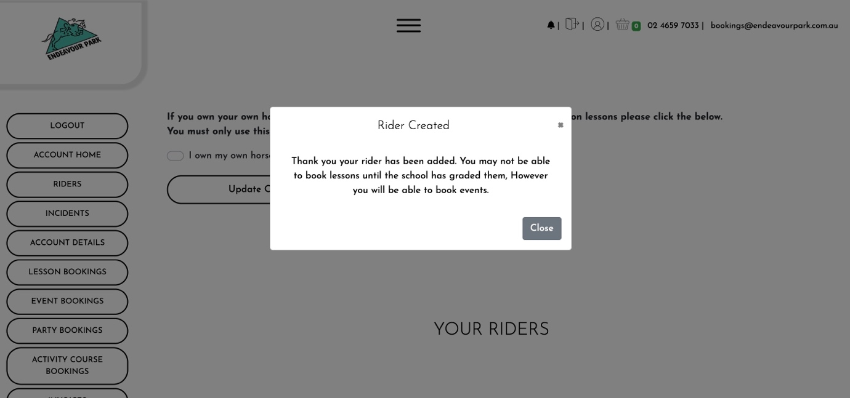

- If you haven’t ridden with EPEC previously, once you create a rider profile a message may appear saying you cannot book until you have been graded by us. Please note that you CAN book lessons even if you’re ungraded and only lessons suitable for ungraded riders will be shown. Once you're graded after your first lesson, more lessons will show up. Grading will be done in your first lesson. If no lessons appear please contact us to arrange a session.
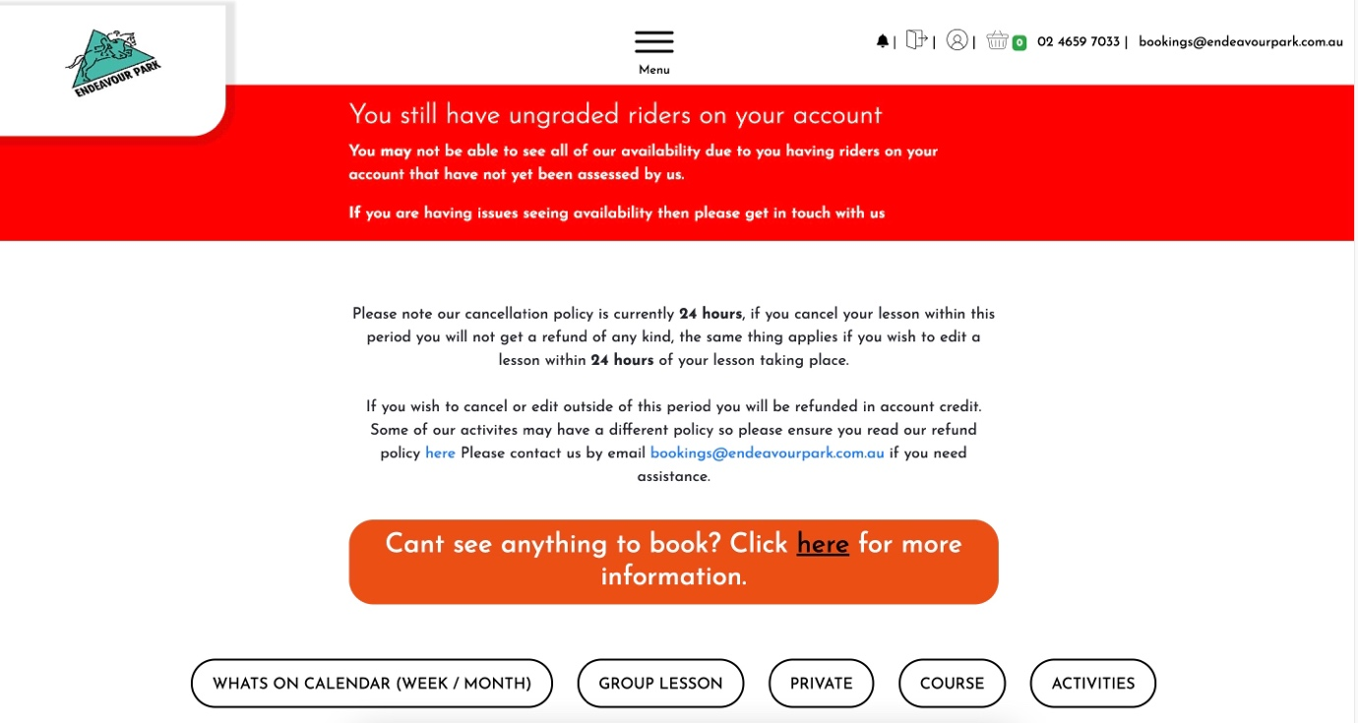

MAKE A BOOKING
1. Select MAKE A BOOKING from the main page
2. Click on the calendar date, and select a date you wish to check availability for

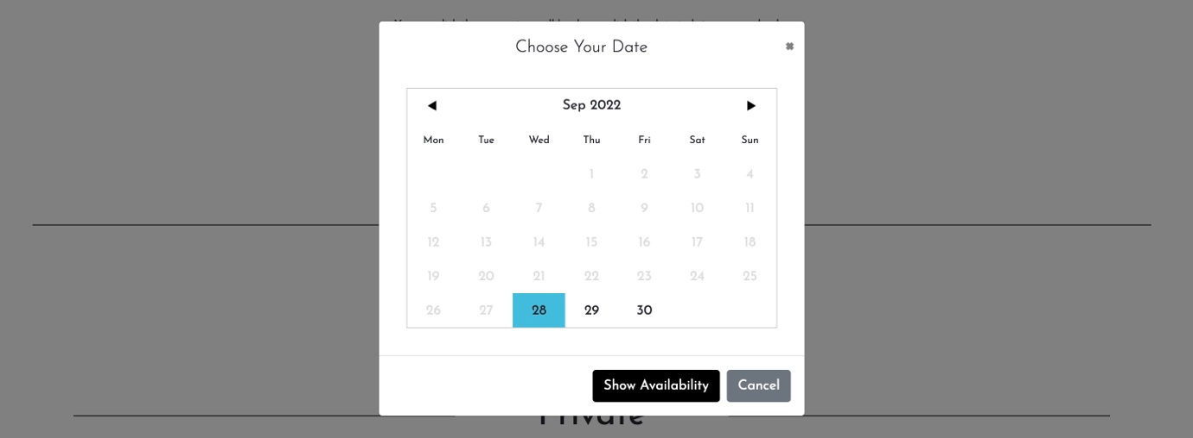

3. Select a time that works for you. Remember this is your riding time and we will request that you arrive 15minutes before this time to prepare for your lesson. When selecting a time keep this in mind.
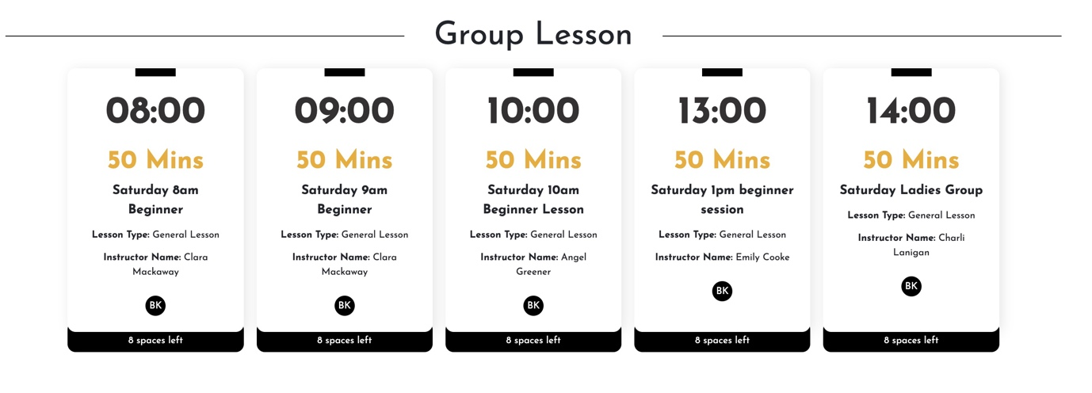
For private sessions you will see available times under the subheading – PRIVATE
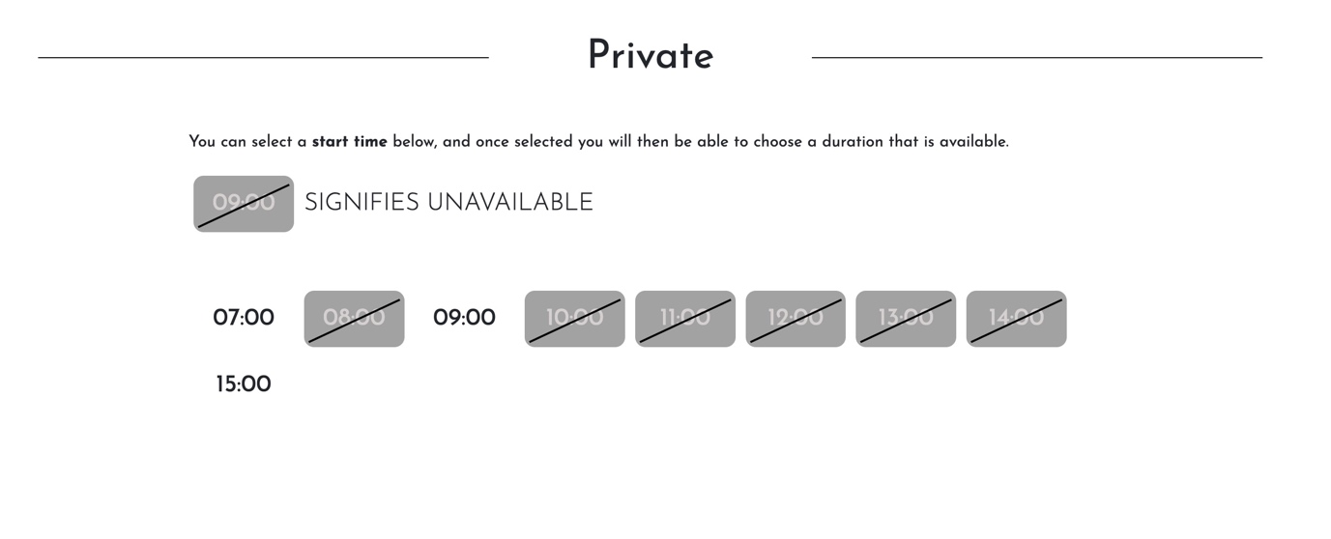
4. Check all details in STEPS, as well as the lesson summary on right of the page
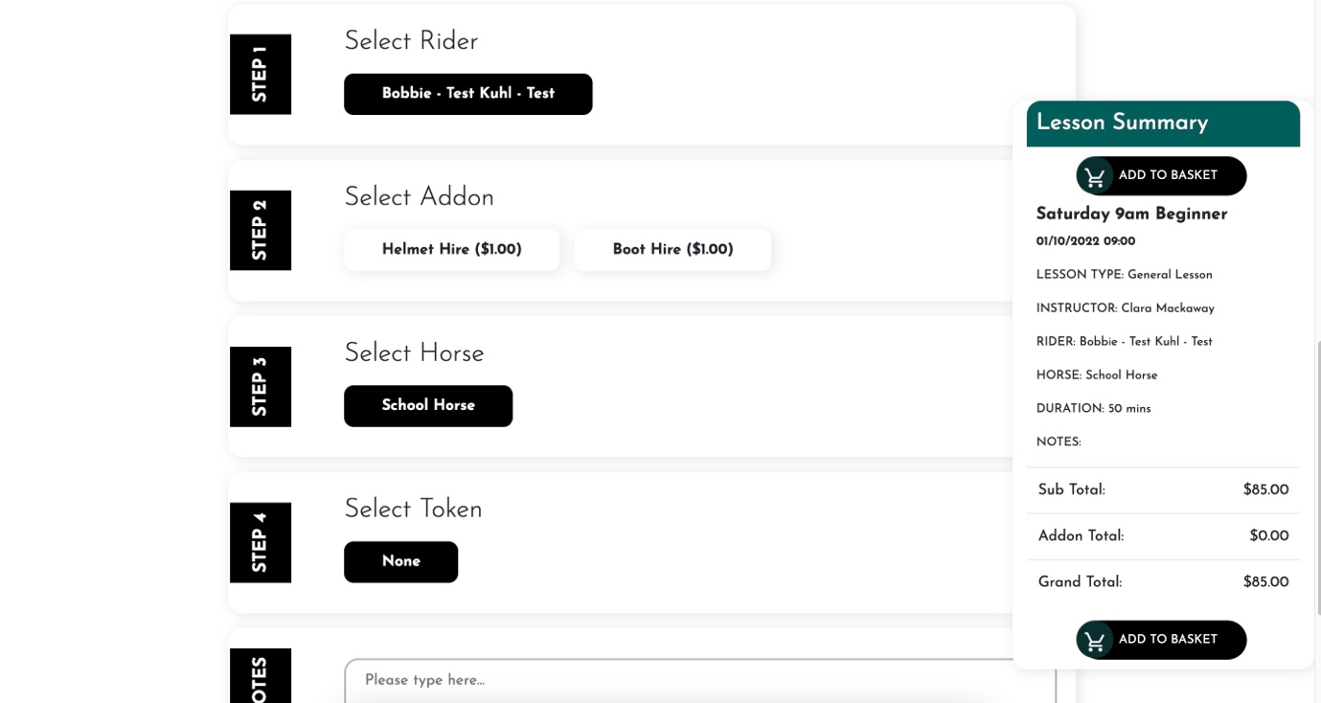

5. If you have any special needs or requirements, please make a note in the notes box
6. Add to basket
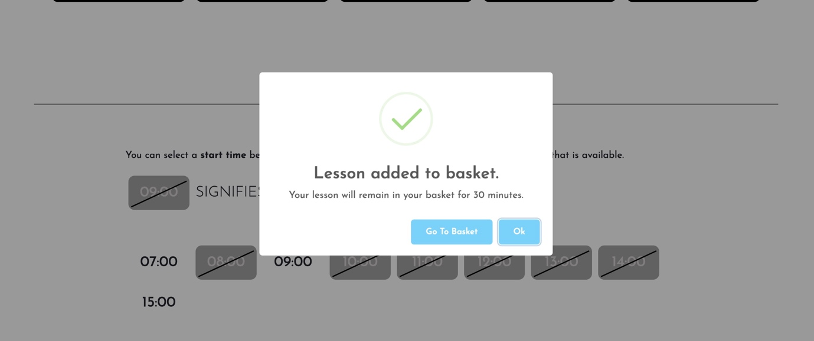

7. Go to basket, and checkout
8. If you have a credit you wish to use, this will appear at the payment stage of checkout. Follow prompts to add credit

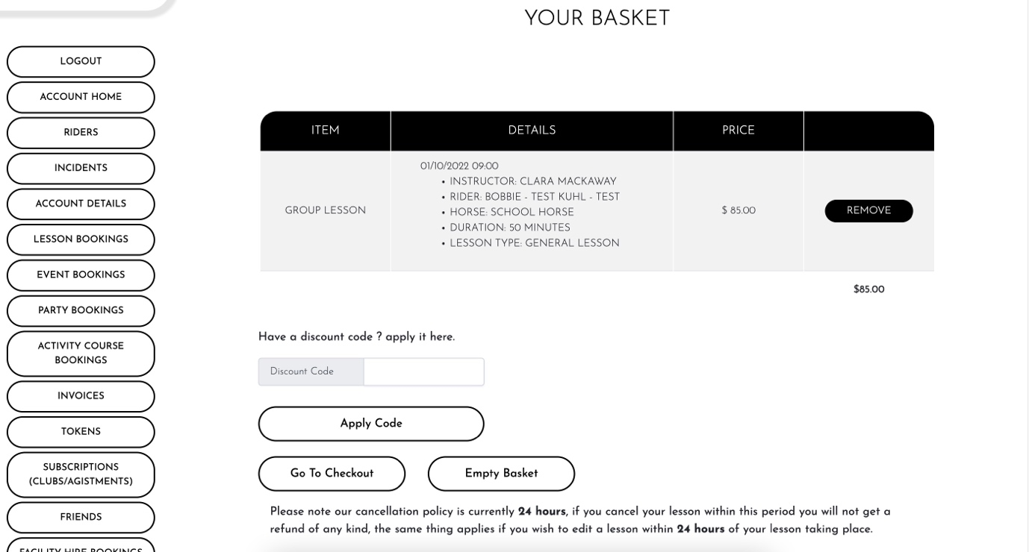

9. If no credit is available, add your card details and make a payment to finalise your booking 10. You will then receive an automated confirmation email. If you do not receive this, please check in with us. Be sure to arrive 15 minutes prior to your booking time

